Name :Sk.Kashifa

Registration no:192121135

Exam registration system :

Usecase :

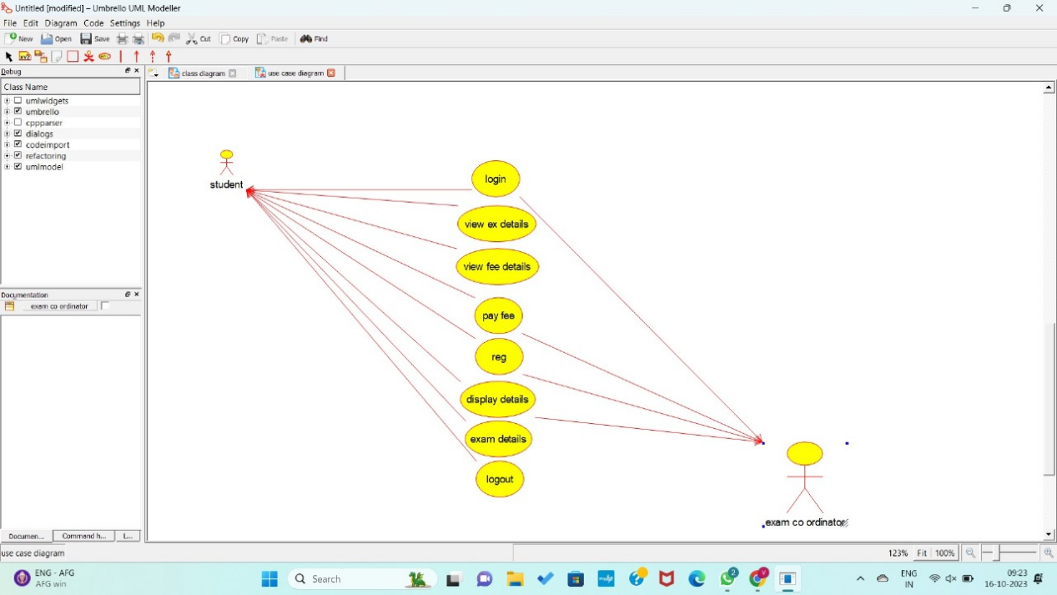

Sequence diagram :

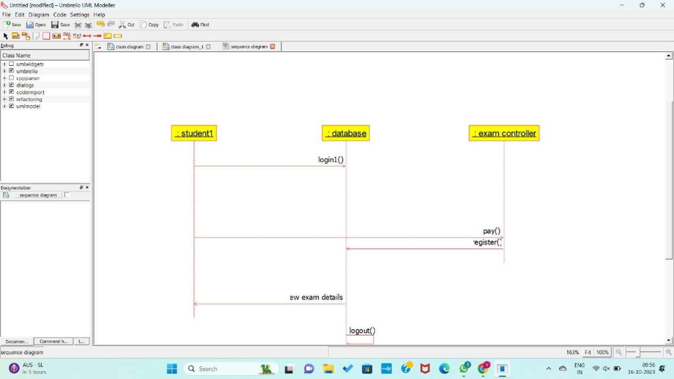

Component diagram :

